A

Mini Project report

On

**DETECTING NODE FAILURES IN MOBILE WIRELESS NETWORKS:A PROBABILISTIC APPROACH**

(Submitted in partial fulfillment of the requirements for the award of Degree)

BACHELOR OF TECHNOLOGY

in

COMPUTER SCIENCE AND ENGINEERING

BY

**V.SAI CHARAN (147R1A05N6)**

**A.V.SAI SARANYA (147R1A05J6)**

**SHALINI SINHA (147R1A05N5)**

Under the Guidance of

**Mr.B.P DEEPAK KUMAR**

(Assistant Professor)



**DEPARTMENT OF COMPUTER SCIENCE AND ENGINEERING**

**CMR TECHNICAL CAMPUS**

(Accredited by NBA, Permanently Affiliated to JNTUH, Approved by AICTE, New Delhi)

Recognized Under Section 2(f) & 12(B) of the UGC Act.1956,

Kandlakoya (V), Medchal Road, Hyderabad-501401.

2014-2018

**DEPARTMENT OF COMPUTER SCIENCE AND ENGINEERING**



### **CERTIFICATE**

This is to certify that the project entitled “**DETECTING NODE FAILURES IN MOBILE WIRELESS NETWORKS:A PROBABILISTIC APPROACH**” being submitted by **V.SAI CHARAN(147R1A05N6), A.V.SAISARANYA(147R1A05J6), SHALINI SINHA(147R1A05N5)**in partial fulfillment of the requirements forthe award of the degree of B.Tech in Computer Science and Engineering of theJawaharlal Nehru Technological University Hyderabad, during the year 2017-2018. It is certified that she has completed the project satisfactorily.

**INTERNAL GUIDE DIRECTOR**

**Mr. B.P.DEEPAK KUMAR Dr. A. Raji Reddy**

**Assistant Professor**

**HOD EXTERNAL EXAMINER Dr. K. Srujan Raju**

**Submitted for viva voce Examination held on ____________________**

**ACKNOWLEDGEMENT**

Apart from the efforts of us, the success of any project depends largely on the encouragement and guidelines of many others. We take this opportunity to express our gratitude to the people who have been instrumental in the successful completion of this project.We take this opportunity to express my profound gratitude and deep regard to my guide

**Mr.B.P. DEEPAK KUMAR,** Assistant Professor for his exemplary guidance, monitoring and constant encouragement throughout the project work. The blessing, help and guidance given by him shall carry us a long way in the journey of life on which we are about to embark.

We also take this opportunity to express a deep sense of gratitude to Project Review Committee(PRC)coordinators: **Mr.J.Narasimha Rao(Assoc.Prof.), Mr.R.NagaRaju (Assoc.Prof.), Mrs.Suwarna Gothane(Assoc.Prof.), Mr.K.Murali(Assoc.Prof.)**, **V.NareshKumar(Assoc.Prof.)** and **P.Satyavathi(Asst.Prof.)** for their cordial support, valuable information and guidance, which helped us in completing this task through various stages.

We are also thankful to the Head of the Department **Dr. K. Srujan Raju** for providing excellent infrastructure and a nice atmosphere for completing this project successfully.

We are obliged to our Director **Dr. A. Raji Reddy** for being cooperative throughout the course of this project. We would like to express our sincere gratitude to our Chairman Sri. **Ch. Gopal Reddy** for his encouragement throughout the course of this project.

The guidance and support received from all the members of **CMR TECHNICALCAMPUS** who contributed and who are contributing to this project, was vital for the success of the project. We are grateful for their constant support and help.

Finally, we would like to take this opportunity thank our family for their constant encouragement without which this assignment would not be possible. We sincerely acknowledge and thank all those who gave support directly and indirectly in completion of this project.

**V.SAI CHARAN (147R1A05N6)**

**A.V.SAI SARANYA(147R1A05J6)**

**SHALINI SINHA (147R1A05N5)**

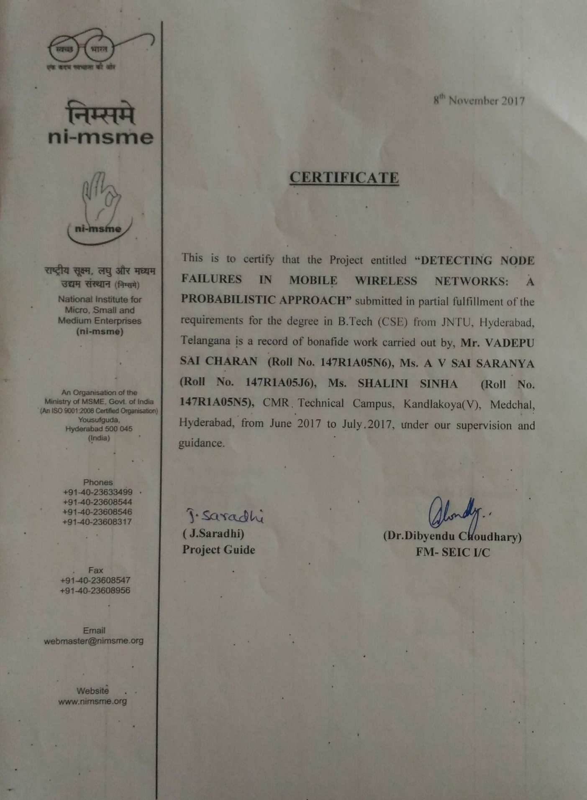

**ABSTRACT**

Detecting node failures in mobile wireless networks is very challenging because the network topology can be highly dynamic, the network may not be always connected, and the resources are limited. In this paper, we take a probabilistic approach and propose two node failure detection schemes that systematically combine localized monitoring, location estimation and node collaboration. Extensive simulation results in both connected and disconnected networks demonstrate that our schemes achieve high failure detection rates (close to an upper bound) and low false positive rates, and incur low communication overhead. Compared to approaches that use centralized monitoring, our approach has up to 80 percent lower communication overhead, and only slightly lower detection rates and slightly higher false positive rates. In addition, our approach has the advantage that it is applicable to both connected and disconnected networks while centralized monitoring is only applicable to connected networks. Compared to other approaches that use localized monitoring, our approach has similar failure detection rates, up to 57 percent lower communication overhead and much lower false positive rates (e.g., 0.01 versus 0.27 in some settings).

**I**

**TABLE OF CONTENTS**

**Page No’s**

ABSTRACT i

LIST OF FIGURES ii

LIST OF TABLES iii LIST OF SCREENSHOTS iv

1. **INTRODUCTION 1**
   1. PROJECT SCOPE 1
   2. PEOJECT PURPOSE 1
   3. PROJECT FEATURES 1
2. **SYSTEM ANALYSIS 2**
   1. PROBLEM DEFINITION 2
   2. EXISTING SYSTEM 2
      1. LIMITATION OF EXISTING SYSTEM 2
   3. PROPOSED SYSTEM 3
      1. ADVANTAGES OF PROPOSED SYSTEM 3
   4. FEASIBILITY STUDY 4
      1. OPERATIONAL FEASIBILITY 4
      2. ECONOMIC FEASIBILITY 4
      3. TECHNICAL FEASIBILITY 4
   5. HARDWARE & SOFTWARE REQUIREMENTS 5
      1. HARDWARE REQUIREMENTS 5
      2. SOFTWARE REQUIREMENTS 5

**ii**

1. **ARCHITECTURE 6**
   1. PROJECT ARCHITECTURE 6
   2. MODULES DESCRIPTION 6
      1. LOCALIZED 6
      2. LOCATION 6
      3. NODE COLLABORATION 6
   3. USE CASE DIAGRAM 7
   4. CLASS DIAGRAM 8
   5. SEQUENCE DIAGRAM 9
   6. ACTIVITY DIAGRAM 10
2. **IMPLEMENTATION 11**
   1. SAMPLE CODE 11
3. **SCREEN SHOTS 12**
4. **TESTING 24**
   1. INTRODUCTION TO TESTING 24
   2. TYPES OF TESTING 24
      1. UNIT TESTING 24
      2. INTEGRATION TESTING 25
      3. FUNCTIONAL TESTING 25
   3. SYSTEM TESTING 26
      1. USER ACCEPTANCE TESTING 26
      2. OUPUT TESTING 27
      3. VALIDATION TESTING 27
      4. USING LIVE TEST DATA 28
      5. USING ARTIFICIAL TEST DATA 28
5. **CONCLUSION** **29**
   1. PROJECT CONCLUSION 29
   2. FUTURE ENHANCEMENT 29
6. **BIBLIOGRAPHY 30**
   1. REFERENCES AND WEBSITES30

**iii**

**LIST OF FIGURES**

**FIGURE NO. FIGURE NAME PAGE NO**

Fig. 3.1 Project Architecture 6

Fig. 3.2 Use case diagram 7

Fig. 3.3 Class diagram 8

Fig. 3.4 Sequence diagram 9

Fig. 3.5 Activity Diagram 10

**iv**

**LIST OF SCREENSHOTS**

**SCREENSHOT NO. SCREENSHOT NAME PAGE NO**.

5.1 Screenshot ROUTER 12

5.2 Screenshot SOURCE 13

5.3 Screenshot RECEIVER 1 14

5.4 Screenshot RECEIVER 2 15

5.5 Screenshot NODE SELECTION 16

5.6 Screenshot NODE STATUS 17

5.7 Screenshot CHOOSING RECEIVER 18

5.8 Screenshot TIME SELECTION 19

5.9 Screenshot IP ADDRESS SELECTION 20

5.10 Screenshot DATA TRANSMISSION 21

5.11 Screenshot RECEIVER DATA 22

5.12 Screenshot REPORT 23

**v**